Performance Measures for Regression
We will describe the most popular performance measures used for continuous targets. We have a test set containing instances for which we know the correct target values, and we have a set of predictions made by a model. We would like to measure how accurately the predicted values match the correct target values.

Basic Measures of Error

The most basic performance measure for continuous targets is sum of squared errors. The sum of squared errors function, L2, for a set of predictions made by a model, h, is defined as

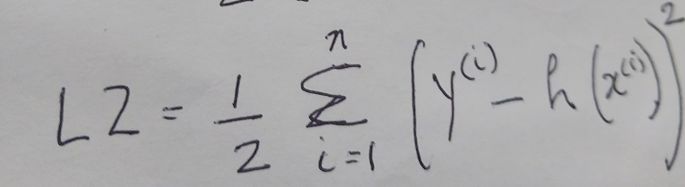

where y^{(i)} is the target variable and h(x^{(i)}) is the model prediction. This can be modified very slightly to give us the mean squared error performance measure, which captures the average difference between the expected target values in the test set and the values predicted by the mode. This iscalled Mean Square Error, MSE and is given by

MSE = L2/n.

Lower values of MSE indicate better model performance. Although it can be used to effectively rank models, the actual mean squared error values themselves are not especially meaningful in relation to the scenario that a model is being used for. This is due to the use of the squared term in the mean squared error calculation but can easily be addressed by using the Root Mean Square Error (RMSE). It measures the standard deviation of the errors the system makes in its predictions.

h represents our model, h(x^{(i)}) represents the prediction of one instance and y^{(i)} is the target value for that instance.

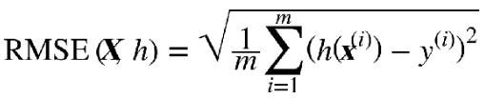

The mathematical formula to compute the RMSE is shown above.
Suppose we are going to predict housing prices (y) in districts in Kerala based on latitude (x), longitude (x), population (x), median salary (x) and represent our model as h. (Practically of course, many other features will have to be considered to get a realistic model). Suppose we have 2000 instances, m = 2000. To assess the relationship that the first four features (x) have to obtain the value of housing, (y), we need a dataset that includes the y value for each combination of features. Each such combination is an instance. For example, if we take Idukki district the 4 x values are 9.9189° N, 77.1025° E, 1,541,474 and 23,000 and the median housing price 12,00,000. We can picture our dataset as follows
Lat | Long | Population | Median salary | Housing price
9.9189° N | 77.1025° E | 1,541,474 | 23,000 | 12,00,000
......
....
...
In data science, we represent it as a matrix X with the features/independent variables/predictors as columns. The dependent variable, or the value being predicted or the target is also a column. One row of the matrix is an instance. It is represented as follows
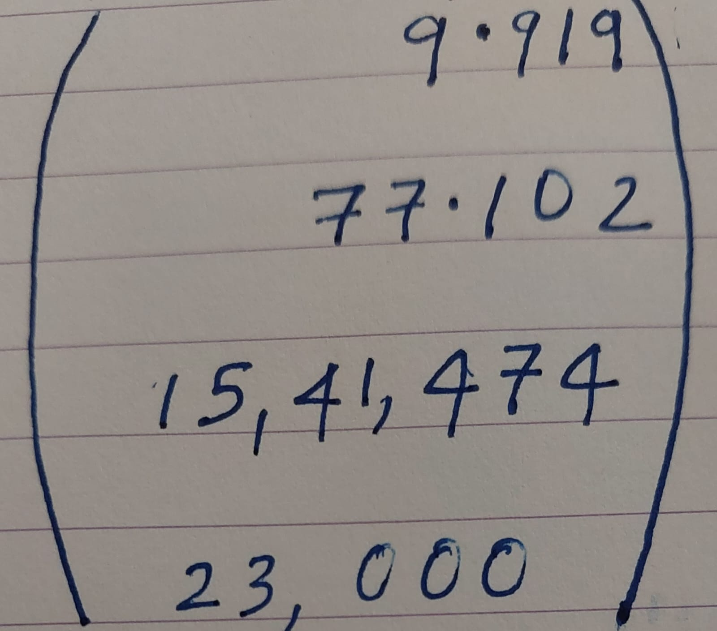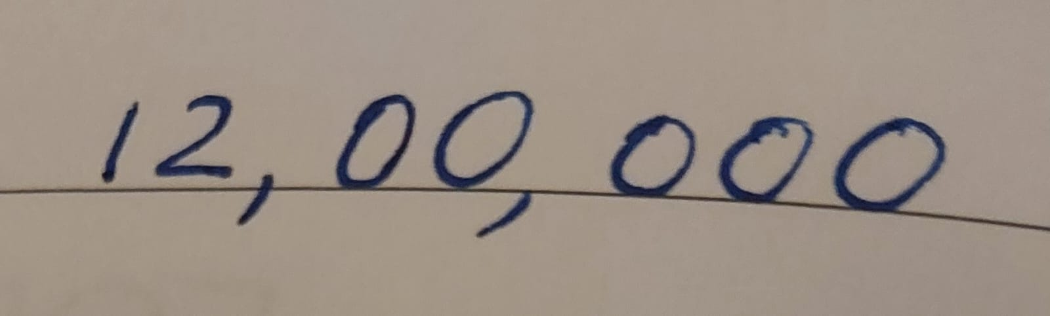
x⁽¹⁾ =
y⁽¹⁾ =
X is a matrix containing all the feature values (excluding labels) of all instances in the dataset. There is one row per instance and the i^{th} row is equal to the transpose of x^{(i)}, noted (x^{(i)})^{T}
Thus matrix X looks as follows
